Te Reo Maori Resource Sheet – Week 1

Kia ora koutou
In response to the request in team meetings to support teachers in learning things Maori I have introduced weekly Te Reo Maori focus and associated support resources may be helpful in getting more authentic, integrated reo into the classroom.

Ka Mau te Wehi is a great resource and will support any teacher who is struggling to feel confident in integrating te reo in the daily classroom setting.
By following the video and completing the activities teachers will be able to easily follow the step by step lessons that are based around the everyday living of a group of tamariki.

how learning te reo and the understanding of all cultural differences can be advantageous in all learning programmes not just in the learning of things Maori.

Take some time to read this page and think about how you can use TPTs – eg: blackboard splash to make connections to learning Maori and to all other learning.

If you click on the website below you will find a 2 - 4 minute te reo session that would be incredibly easy to integrate into the classroom programme.
It is step-by-step, simply put and interactive for students.

http://www.tokureo.maori.nz/index.cfm/1,195,0,43,html?p=1 (podcast)
Series 1: Episode 1: vowel sounds, basic greetings
Main vocabulary introduced: kai, whare, ra, kaumatua, po toku, reo, koe, korua, koutou.
Series 1: Episode 2: Revise greetings and vocabulary with an introduction into listening to a conversation in Maori.
Series 1: Episode 3: vowel sounds, greetings using a someone’s name
Main vocabulary: hoa, mama, tane, kotiro, tamaiti, pepi, kuia, papa.
(this episode mentions ‘loaned words from the English language) there are two ‘loaned words in the vocabulary list.
Series 1: Episode 4: Vowels, Revise greetings using personal names
Series 1: Episode 5 : Revise the weekly words and applications.

Include Unit 1 Ata marie into your programme this week.
The learning intention?WALT is included in the unit plan and it is set out step by step with the resources associated.
The scenarios and Waiata DVD give you an authentic example of te reo
He Korero Whakamarama – useful information that is relevant to all learners.
Why we ask where someone is from.
The use of macron - tohuto
Use of tukakana and teina
Use of ne
Use of whaea

Please note I have not printed the tohuto in this information sheet so feel free to take in on during the lessons to add them in.

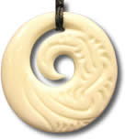
Koru (spiral) is the Beginning of Life. The Maori have taken their symbolism from the unfurled new leaf of the silver fern. It depicts new beginnings, growth and harmony. New Zealand is the home of the most beautiful ferns in the world.
http://www.giftsnz.com/green.htm

Whakataukī (proverbs)

Whakataukī play a large role within Maori culture. They are used as a reference point in speeches and also as guidelines spoken to others day by day. It is a poetic form of the Maori language often merging historical events, or holistic perspectives with underlying messages, which are extremely influential in Maori society.
Proverbs are very fun to learn and loaded with advantages within language learning. They can be interpreted as you see fit, and as your Maori improves try translating them to dive deeper in their meanings. There are countless proverbs and it will be very useful for you to remember as much as you can. Below are some of the many that exist.
Kaua e mate wheke mate ururoa
Don't die like a octopus, die like a hammerhead shark

Octopus are renown for their lack of resistance when being captured, however a hammerhead shark will fight bitterly to the end, to the point that when you fillet it fresh, its meat quivers. Commonly used to encourage someone not to give up, no matter how hard the struggle is.
http://www.maori.cl/Proverbs.htm

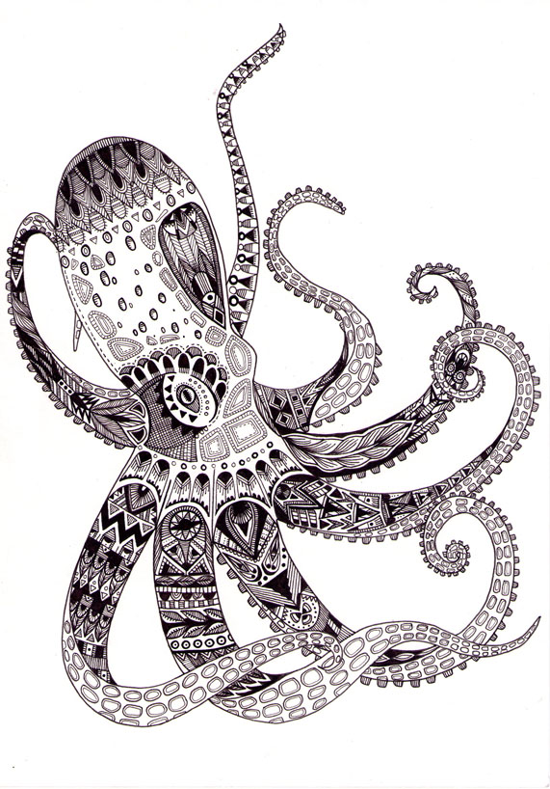

Try some SIR (small, intricate, repetitive) on the hammer shark. The octopus is a good example of SIR.

